2017 Ruby’s Rainbow Sponsorship Packet
Meet some of our Rockin’ Recipients

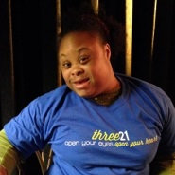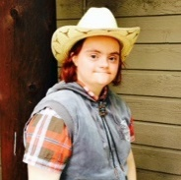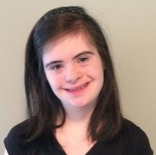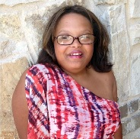

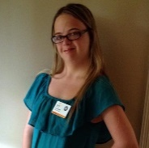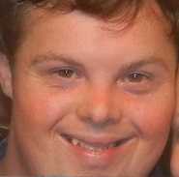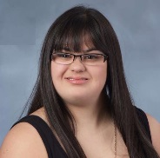

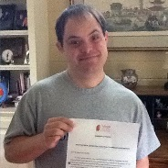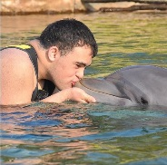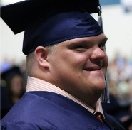

Ruby’s Rainbow is a nonprofit organization dedicated to helping adults with Down syndrome reach their highest potential. Our mission is to grant scholarships to adults with Down syndrome who are seeking post-secondary education, enrichment or vocational classes. Life and learning don’t stop after high school, after all — and at Ruby’s Rainbow, we believe education shouldn’t stop, either. For individuals with Down syndrome, the college experience is about gaining independence, building new relationships, rising to challenges and reaching for the stars — and grabbing them!
Ruby’s Rainbow has granted $295,000 in educational scholarships to 109 Rockin’ Recipients — and counting. Becoming a Ruby’s Rainbow sponsor is an excellent opportunity for you or your business to contribute to this wonderful cause. Please take a few moments to look over the following information and learn more about donating.
Become a Sponsor for the Ruby’s Rockin’ RainBOWL Tournament

One of two annual Ruby’s Rainbow fundraisers, the Rockin’ RainBOWL is a fun family event attended by over 350 participants — a bowling tournament with live music held at Dart Bowl in central Austin. This year’s RainBOWL will be held on July 16, 2017.

The “Spare”! $250 – Our introductory sponsorship level, the “Spare,” includes name recognition as a donor on our sponsor page for one year. For no extra charge, we’ll also throw in “that giddy little feeling you get inside” when helping an individual with Down syndrome achieve their dreams of higher education.

The “Lucky Strike”! $500 – This sponsorship level gets your business logo a spot on our super-cool event shirt as well as on our sponsor page, where it will link directly to your website for an entire year! Sponsors at this level will also have the opportunity to promote their business to over 300 fundraiser participants through promotional materials in our goodie bags (materials provided by sponsoring company).

The “Turkey”! $1,000 – Getting three strikes in a row has nothing on this “Turkey”! Sponsorships at this level include all the perks of the “Lucky Strike,” plus premium placement of your company logo on our sponsor page, a company “shout out” during the event, registration for a team of five bowlers, and 10 free raffle tickets!

The “Perfect Game”! $3,000 – You thought a perfect 300 was good… What about 3,000? That’s right! Along with all the perks of the “Turkey,” a $3,000 donation provides enough funding to grant one full scholarship in your or your company’s honor. By sponsoring the “Perfect Game,” you’ll be providing someone with Down syndrome the perfect opportunity to achieve their college dream!

We will also gratefully accept any donation amount. If your business has other grant programs or opportunities available that might be a good fit for our organization, please contact Liz Plachta at 512-879-7801 or liz@rubysrainbow.org.
To learn more about our organization, please visit www.RubysRainbow.org

Ruby’s Rainbow Sponsorship Form

Name of individual or business _________________________________________________________________

Address ______________________________________________________________________________________

City ___________________________________________ State _____________ Zip ________________________

Phone Number ____________________________ Contact Person _____________________________________

Email ________________________________________________________________________________________

Please check sponsorship level:

____ $250 – The “Spare”! Name to be displayed on website: _______________________________________

____ $500 – The “Lucky Strike”!

____ $1,000 – The “Turkey”! Please write your team name: ________________________________________

____ $3,000 – The “Perfect Game”! Please write your team name: _________________________________
Name or business name as you would like it to appear on our Rockin’ Recipients page (Example: “The Arehart Family Scholarship Award”):

________________________________________________________________ Scholarship Award

Please contact Liz Plachta at liz@rubysrainbow.org to submit your business logo
and arrange for delivery or pick-up of your marketing materials (if applicable)

We also greatly appreciate in-kind donations for our raffles and silent auctions!

____ In-Kind Donation/Item Description: _________________________________________________________

Approximate Value: $____________________

____ Any donation amount: $____________________

Make checks payable to Ruby’s Rainbow and submit via mail, with this form, to:
Ruby’s Rainbow, Inc.
P.O. Box 153095
Austin, TX 78715
OR EMAIL Liz@Rubysrainbow.org to pay online!!

Thank you so much for helping individuals with Down syndrome achieve their dream of college!

Questions? Please contact Liz Plachta: 512-879-7801 or Liz@rubysrainbow.org

